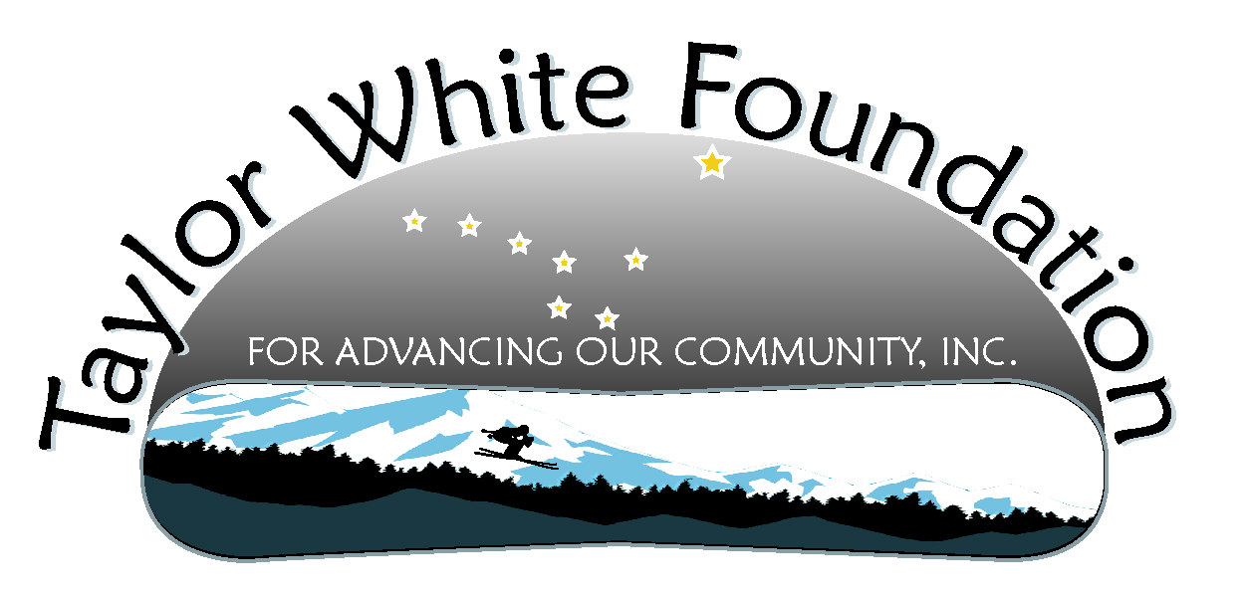
Taylor White Foundation Board Meeting
April 3, 2011

Attending: Kristen, Sam, Justine, Tyler, Morgan, Linda, Carol, Kevin and guest Joe Emerson
Absent: Katie, Lauree, Haleigh

Item |  | Action Items
- Treasurer’s Report | $25,414.62
- Under 21 Club/Event  - Current Status  - Report on kids who might be interested  - Next steps  - Form workgroup | Linda has 3 other teens interested in the project. Alex is interested in doing a brainstorming with the group but needs to do it this month as he is leaving in early May. Sam and Linda will set up a meeting toward the end of the month that accommodates Sam’s travel. The idea was also proposed to invite Andy Kline to get involved as he recently put on a rave. Pat Race and crew might also be good resources for creative ways to do the rave.  Shona’s idea of having a roller rink that might be sort of the anchoring activity and money maker for the Under 21 Club was discussed. The board thought the idea was great and is interested in pursuing the potential. Sam suggested maybe even seeing about renting skates and having an event to build interest.  Other ideas that we talked about was getting Karoke into whatever club we ended up with. Linda said the kids like karoke. | Sam and Linda will hold meeting to bring Under 21 Club event to life before the end of April.  Sam will look online to see if there are skate rental outfits we could get skates up here for and what the costs would be.
- Car Display Update  - Trailer  - Display  - Next steps  - Scheduling  - Form workgroup | Kevin said the car should be “melted out” and will be contacting the tow truck with plans to have the car out and loaded on the trailer by the end of the week. He may need to get a forklift to do this work. Sam said he would help Kevin.  It was decided to contact the art teachers at TMHS and JDHS to see if they would have students design the message and display and help execute. We have good carpentry expertise within the Foundation to support the execution. We will plan to have a party for all volunteers and give out sweatshirts once the project is completed. We need to have this ready to go at least by graduation if not before.  Kristen said the principal at TMHS had seen a crashed car display used before and that it was the most effective tool he had seen.  We discussed where we would use the display outside of school campuses and both Fish Creek on Douglas and the pullout past Eagle Beach were mentioned. More discussion is needed.  If we are unable to get the high school art teachers/students involved it was suggested we talk with Shona at Perseverance. | Linda was going to approach Jan Neimeyer at TMHS  Kevin will call Heather Ridgeway at JDHS and will also meet with Jan to talk about details.  Kristin will talk with the principals to see if we will have permission to put the car on the high school campus.  Justine will talk to Tom Nave to see if he has kids that need to do community service hours during April that could help with the display.
- Driver’s Training  - Current status  - Funding opportunities  - Next steps | Lisa Corcoran emailed Kevin and Carol to say they are planning to do driver’s training in Juneau and have begun doing the groundwork for that. They are interested in partnering, and especially interested in financial help. Kevin has reached out to Lisa but has not been in contact yet. He will continue to try to reach her.  Carol did not apply for the Allstate grant as she didn’t have enough information about the particulars of the project to complete the application.  However she did hear from SEARHC that they should hear whether we were awarded the supplemental money of between $20,000-$30,000 for the driver’s training project by April 6. | Kevin to meet with Lisa to determine what help they need from us.
- Documentary  - Web Analytics Report  - Anchorage – any news from Kristen’s contact?  - Juneau High Schools  - Report on conversations with middle schools | Morgan reported there is an average of 3 video viewings per day during March with 78 total for the month.  Once Morgan returns to Juneau for the summer Carol would like to talk with Morgan about ways they can increase traffic to the website and particularly the video.  The suggestion was made to have the website advertised at the movie theaters. You have a captive, bored audience and the advertising was believed to be around $500 per month. Alaska Grafix is the company to contact. Kristen said we need a short concise tagline about the mission of the Foundation along with the web address. We would want to advertise during the spring  Morgan put out a request on Facebook asking kids to come up with the statement. We will give a sweatshirt to the winner.  Kristen is working on getting Aftermath on the school district cable and publicizing the schedule so parents and kids can watch it together.  Kristen also talked with Sally Donaldson at DZ about using the documentary with the 8th grade students. They talked about 2 venues. 1) using the documentary as part of their prevention curriculum or 2) including it in a parent/student event. Sally and Chrissie Walker are goig to review the documentary and determine appropriateness for 8th graders.  Lauree was not at the meeting so Carol will email Lauree to see what she learned from Floyd Dryden.  The funding for prevention education was cut for next year at the middle schools, so the counselors are responsible for all of it. This is a good time to be working with the counselors. | Tyler will talk with Pat to see if he would design the “slide”.  Carol will call Alaska Grafix to get the specifics on advertising with them  .  Carol will contact Bob Swanson about the video viewing at TMHS  Kristen will follow up with Sally Donaldson  Carol will follow up with Lauree to see what Floyd Dryden is interested in as far as the documentary.  Kevin will coordinate with Pat on how to get the advertisement to AK Grafix.  Carol will coordinate getting the designs to Aurora Projekt for the sweatshirts.
- Awareness  - Sign by highway in memory of Taylor  - Give aways for the 8th grand dances May 20 and 21 | DZ is interested in building awareness about safe fun things for kids to do. They would like to have the wrist bands and sweatshirts. Everything needs to be accompanied by that concise statement about the Foundation’s mission, so once we have that developed we will use it with these “awareness builders”.  Kristen brought a DVD of the school district’s video “Consequences” produced by Mikko Wilson. Carol will be taking it to Petersburg to share with them.
- Youth Recruitment  - Meeting with Nancy and Bob Swanson  - JDHS Representative | Carol and Ulla met with Nancy Seamont and Bob Swanson. Nancy was unwilling to have kids volunteer with the Foundation because we don’t have abstinence as our primary purpose.  Still need to get a JDHS representative for the board. Carol ask Kristen if she would talk to Paula Casperson for a suggestion. | Kristen will ask Paula Casperson for a suggestion for a JDHS representative for the board
- Next meeting | May 8 5:00-6:30 – please note we will meet ½ hour later than usual.

